**फसल pe hustle**

India holds the record for the second largest agricultural land in the world. Indian Farmers are the most devoted farmers in the entire globe, working nonstop for the sake of their crops day and night. They are revered as idols in India. The majority of people in India work in agriculture in some capacity, earning the country the moniker "land of farmers."

**Our objective:**

Our objective is to educate, instruct and guide under privileged farmers so that they can fraternize their rights and not get exploited by any middleman in the agriculture industry. We also aim to introduce new technologies and innovations to the farmers so that they can contribute better vegetation to the country and can get greater revenues on their crops.

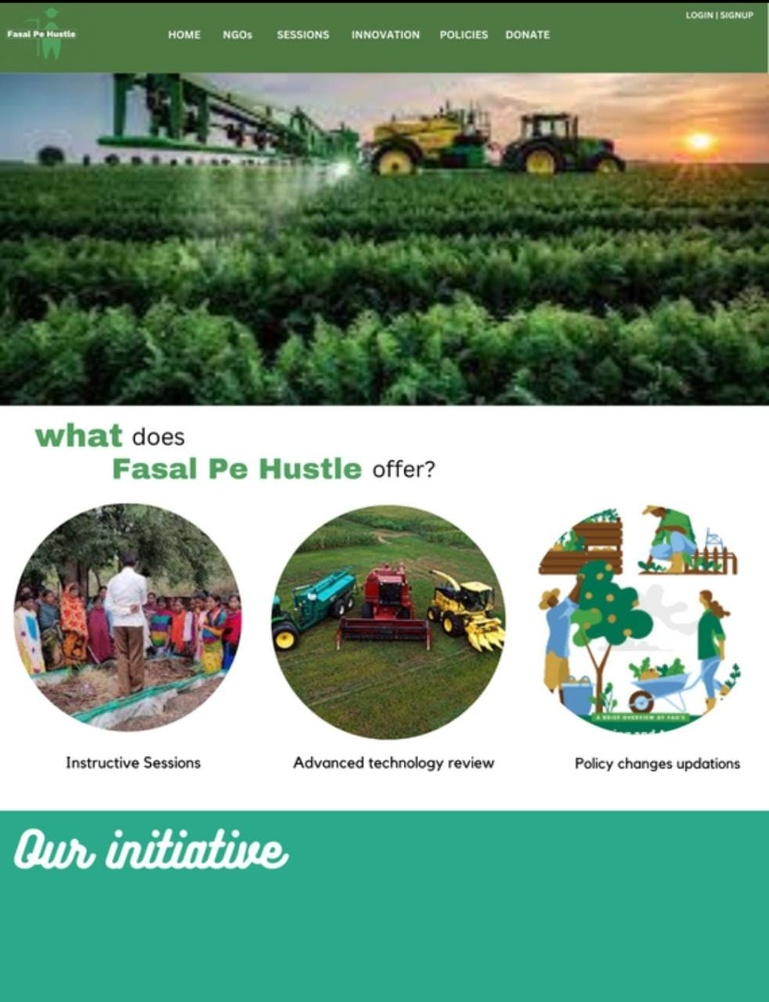

This is home page. We connect the various NGOs with farmers so that they can provide free camp and agriculture advice to farmers. We will provide options like policies for introducing the new and revived policies to farmers, innovations in that farmers can see and known about variety of machines, donations for people like us who can donate whatever amount of money they wish.

